GOVERNORS' STATEMENT OF BEHAVIOUR PRINCIPLES

The Education and Inspections Act 2006 and DfE document Behaviour and discipline in schools: guide for governing bodies (September 2015) requires the governing body to make and frequently review a written statement of general behaviour principles to guide the headteacher in determining measures to promote good behaviour.

We are a UNICEF Rights Respecting School. These principles relate to Articles
3,4,5,6,12,13,14,15,16, 18,19,23,28,29,30,31,39

Rationale and Purpose
This Statement has been drawn up in accordance with the Education and Inspections Act 2006, and DfE guidance (The school behaviour policy: the role of the governing body) and the Equality Act 2010.
The purpose of this statement is to provide guidance for the headteacher in drawing up the Kielder Primary School Behaviour Policies (Positive Behaviour, Anti-Bullying) so that they reflect the shared aspirations and beliefs of governors, staff, parents and carers for the children in the school, as well as taking full account of law and guidance on behaviour matters. Staff should be confident that they have the governors’ support when following this guidance.
This is a statement of principles, not practice: it is the responsibility of the headteacher to draw up the Behaviour Policies at Kielder Primary School, though they must take account of these principles when formulating this.

The headteacher is also asked to take account of the guidance in DfE publication Behaviour and Discipline in Schools: a guide for headteachers and school staff (January 2016).
The Behaviour Policies must be publicised, in writing, to staff, parents/carers and children each year. It must also appear on the school’s website.

Our Behaviour Principles reflect our school values, our commitment to the United Nations Convention on the Rights of the Child and our curriculum drivers.
- Kielder is an inclusive school. Everyone should be free from discrimination, harassment, victimisation of any sort. Equity is when everyone gets what they need to achieve.
- Everyone has the right to feel safe all of the time.
- Bullying or harassment of any description is unacceptable even if it occurs outside normal school hours.
- Every pupil should be educated in an environment where they feel valued, listened to and respected
- Children should be encouraged to be accountable for their actions and the potential impact on themselves and others
- Consequences should enable a pupil to reflect on, and learn from a situation and to make reparation wherever possible.
- Children should be supported to build self-discipline, empathy and emotional resilience through the development of strong self-regulation systems.
- Adults in school should model, maintain, encourage and promote positive behaviour and the principles of fairness and justice.
- High expectations for positive behaviours and attitudes towards learning provide the foundations for our children to become confident, resilient and self-assured learners.
- The school should work in partnership with parents/carers to develop and promote positive behaviours - and seek advice from appropriate outside agencies wherever necessary.
- Exclusion from school is a last resort. Any exclusion should be issued in accordance with guidance from the Local Authority.

We subscribe to the six principles of the Thrive Approach:
- We understand that behaviour communicates unmet needs and can separate the child/young person from their behaviour.
- We understand that each developmental stage has a range of typical behaviours, which provide opportunities for adults to role-model and explicitly teach appropriate behaviours.
- We provide containment, predictability and routine to build a sense of safety in the emotional and physical environment.
- We encourage children/young people at our setting to become accountable for their actions and the impact they may have on themselves and others, promoting a solution-focused approach to changing future behaviours.
- We keep in mind that we are the adults and the children/young people are still growing, learning and developing.
- We seek to restore relationships and change behaviours rather than punish the actions a child may have taken. Although this does not exclude the use of sanctions, we seek the most appropriate way of supporting children/young people to develop robust stress-regulation systems and therefore the skills of self-control, empathy and emotional management.
This written statement and the policies that are influenced by it apply to all pupils when in school, when engaged in extra-curricular activities such as educational trips and visits (residential and non-residential) and when travelling to and from school.
The governors wish to emphasise that violence, threatening behaviour or abuse by pupils or parents, towards the school’s staff, will not be tolerated.

We use The Kielder Way to guide all the work we carry out with our children
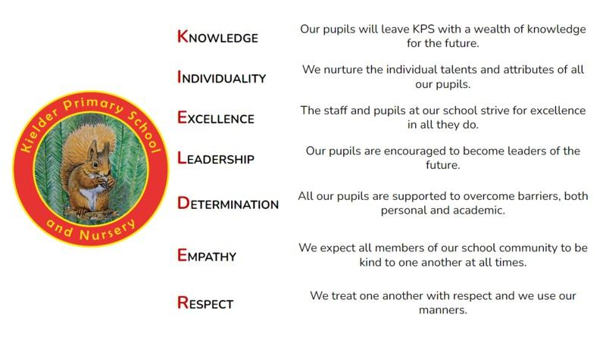

STATEMENT STATUS
Date approved | September 2023
Review cycle | Annual
Next review | September 2024
Approval level | Governing body

