Catering for Children with Food Allergies, Intolerances or who Require a Special Diet
Kielder Primary School & Nursery

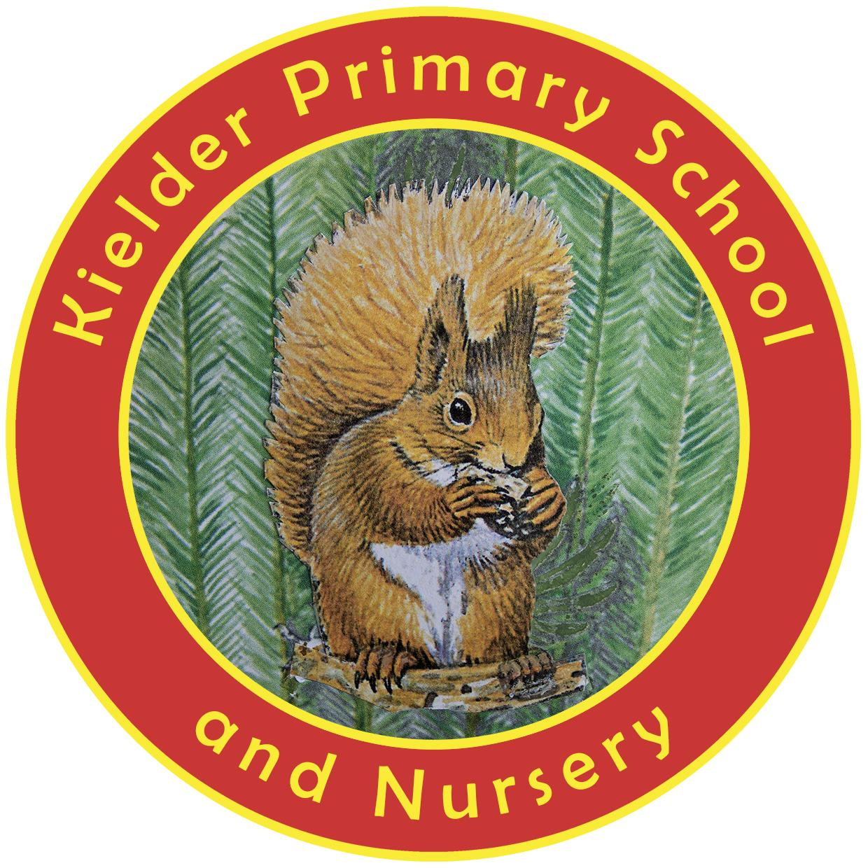
POLICY STATUS

Date approved | September 2023
Review cycle | Every 4 years
Next review | September 2027
Approval level | Headteacher

Our children are offered a hot meal daily. We follow the National Schools Food Standards. Information about these may be found at:
http://www.childrensfoodtrust.org.uk/childrens-food-trust/schools/school-food-standards
School lunch menus are provided by The Boe Rigg and designed for the majority of the school population, so some pupils with special dietary needs may need to be catered for individually. It is up to the school to decide whether this is feasible, although every reasonable effort will be made to cater for all pupils' needs. Food allergies and intolerances affect thousands of children. Other children follow special diets for religious or cultural reasons, or because they are vegetarian or vegan.
Where children require a special diet the following procedure will be followed:
- We will request full information from the child’s parents/carers, so we are fully aware of the foods the child cannot eat.
- If appropriate, we will request written confirmation of the allergy/medical need from the child’s GP, dietician or other medical professional to make sure children are not having foods removed from their diet without a diagnosed medical need.
- We will communicate with the child’s parents/carers (and medical professionals if required) to come up with a clear plan on how to manage their child’s allergy/special dietary requirements in school. This could include identifying foods from the existing school menu that are appropriate for their child, agreeing how existing recipes could be adapted to make them suitable for their child or agreeing how suitable foods can be prepared or supplied for the child.
- We will ensure that The Boe Rigg’s catering staff are fully informed and fully understand about children’s special dietary requirements, and how these are being met, so they can ensure the right food is provided.
There may be occasions where catering staff need training or where extended specialist input is required, such as the support of a dietician. This will ensure children are provided with food appropriate for their needs and a suitable menu is developed.
Although every reasonable effort will be made to cater for all children, there may be occasions where this is not possible. In these cases, children will be encouraged to bring a cold lunch to school. All children at Kielder Primary School sit and eat their lunch together regardless of the type of meal they have.
Clear information will be available so that all staff are aware of children’s allergies, intolerances and dietary requirements.
More information about this can be obtained from the British Society for Allergy and Clinical Immunology (BSACI).

