Early Years Foundation Stage (EYFS) policy
Kielder Primary School & Nursery

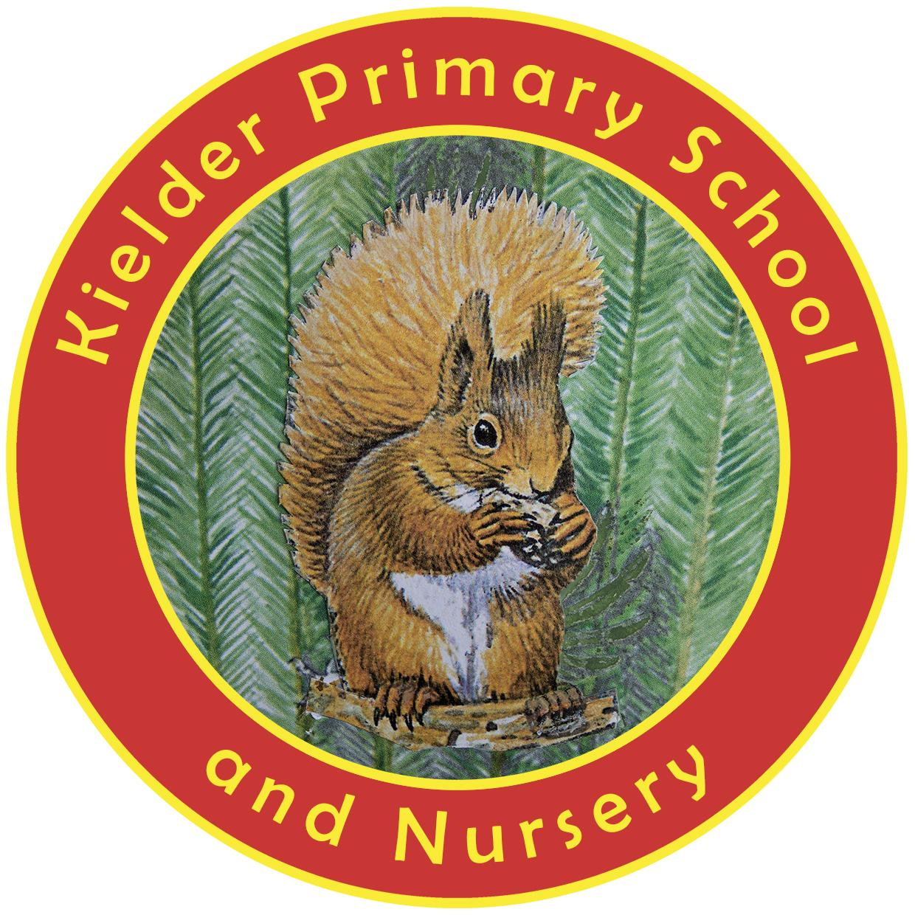

POLICY STATUS

Date approved | September 2023
Review cycle | Every 3 years
Next review | September 2026
Approval level | Governing body (can delegate)

Contents
1. Aims 2
2. Legislation 2
3. Structure of the EYFS 2
4. Curriculum 2
5. Assessment 3
6. Working with parents and carers 3
7. Safeguarding and welfare procedures 4
8. Monitoring arrangements 4
Appendix 1. List of statutory policies and procedures for the EYFS 5

1. Aims
This policy aims to ensure:
- That children access a broad and balanced curriculum that gives them the broad range of knowledge and skills needed for good progress through school and life
- Quality and consistency in teaching and learning so that every child makes good progress and no child gets left behind
- A close working partnership between staff and parents and/or carers
- Every child is included and supported through equality of opportunity and anti-discriminatory practice

2. Legislation
This policy is based on requirements set out in the 2021 statutory framework for the Early Years Foundation Stage (EYFS).

3. Structure of the EYFS
Our EYFS unit takes in children from the age of 3 to 5. We have one dedicated ‘work space’ and one dedicated ‘play space’. This means that younger children are learning alongside older ones with the aim of accelerating progress. A maximum of 30 hours per week is available in nursery. The cost for nursery is £5.00 per hour. In the term after a child’s third birthday, they become eligible for 15 hours of government funding for nursery provision. Some may also qualify for an additional 15 hours, depending on individual circumstances.

4. Curriculum
Our early years setting follows the curriculum as outlined in the 2021 EYFS statutory framework.
The EYFS framework includes 7 areas of learning and development that are equally important and inter-connected. 3 areas, known as the prime areas, are seen as particularly important for igniting curiosity and enthusiasm for learning, and for building children’s capacity to learn, form relationships and thrive.
The prime areas are:
- Communication and language
- Physical development
- Personal, social and emotional development

The prime areas are strengthened and applied through 4 specific areas:
- Literacy
- Mathematics
- Understanding the world
- Expressive arts and design
4.1 Planning
Staff plan activities and experiences for children that enable children to develop and learn effectively. In order to do this, staff working with the youngest children are expected to focus strongly on the 3 prime areas.
Staff also take into account the individual needs, interests, and stage of development of each child in their care, and use this information to plan a challenging and enjoyable experience. Where a child may have a special educational need or disability, staff consider whether specialist support is required, linking with relevant services from other agencies, where appropriate.
In planning and guiding children’s activities, staff reflect on the different ways that children learn and include these in their practice.
4.2 Teaching
Each area of learning and development is implemented through planned, purposeful play, and through a mix of adult-led and child-initiated activities. Staff respond to each child’s emerging needs and interests, guiding their development through warm, positive interaction.
As children grow older, and as their development allows, the balance gradually shifts towards more adult-led activities to help children prepare for more formal learning, ready for year 1.

5. Assessment
At Kielder Primary School, ongoing assessment is an integral part of learning and development processes. Staff observe pupils to identify their level of achievement, interests and learning styles. These observations are used to shape future planning. Staff also take into account observations shared by parents and/or carers.
When a child is aged 3, staff review their progress and provide parents and/or carers with a written summary of the child’s development in the 3 prime areas. This ‘progress check’ highlights the areas in which a child is progressing well and the areas in which additional support is needed.
Within the first 6 weeks that a child starts reception, staff will administer the Reception Baseline Assessment (RBA).
At the end of the EYFS, staff complete the EYFS profile for each child. Pupils are assessed against the 17 early learning goals, indicating whether they are:
- Meeting expected levels of development
- Not yet reaching expected levels (‘emerging’)
The profile reflects ongoing observations, and discussions with parents and/or carers. The results of the profile are shared with parents and/or carers for their child.
The profile is moderated internally (referring to the Development Matters guidance) and in partnership with other local schools, to ensure consistent assessment judgements. EYFS profile data is submitted to the local authority.

6. Working with parents and carers
We recognise that children learn and develop well when there is a strong partnership between staff and parents and/or carers.
Parents and/or carers are kept up to date with their child’s progress and development. The progress check and EYFS profile helps to provide parents and/or carers with a well-rounded picture of their child’s knowledge, understanding and abilities.
Each child is assigned a key person who helps to ensure that their learning and care is tailored to meet their needs. The key person supports parents and/or carers in guiding their child’s development at home. The key person also helps families to engage with more specialist support, if appropriate.

7. Safeguarding and welfare procedures
We promote good oral health, as well as good health in general, in the early years by, for example, talking to children about:
- The effects of eating too many sweet things
- The importance of brushing your teeth
follow Public Health England guidance on supervised toothbrushing to make sure that it is evidence-based and safe.
The rest of our safeguarding and welfare procedures are outlined in our safeguarding policy.

8. Monitoring arrangements
This policy will be reviewed and approved by Lee Ferris, Headteacher, every three years.
At every review, the policy will be shared with the governing board.

Appendix 1. List of statutory policies and procedures for the EYFS

Statutory policy or procedure for the EYFS | Where can it be found?
Safeguarding policy and procedures | See child protection and safeguarding policy
Procedure for responding to illness | See health and safety policy
Administering medicines policy | See supporting pupils with medical conditions policy
Emergency evacuation procedure | See health and safety policy
Procedure for checking the identity of visitors | See child protection and safeguarding policy
Procedures for a parent failing to collect a child and for missing children | See child protection and safeguarding policy
Procedure for dealing with concerns and complaints | See complaints policy

