**Relationships and Sex Education (RSE) Policy**

Kielder Primary School & Nursery

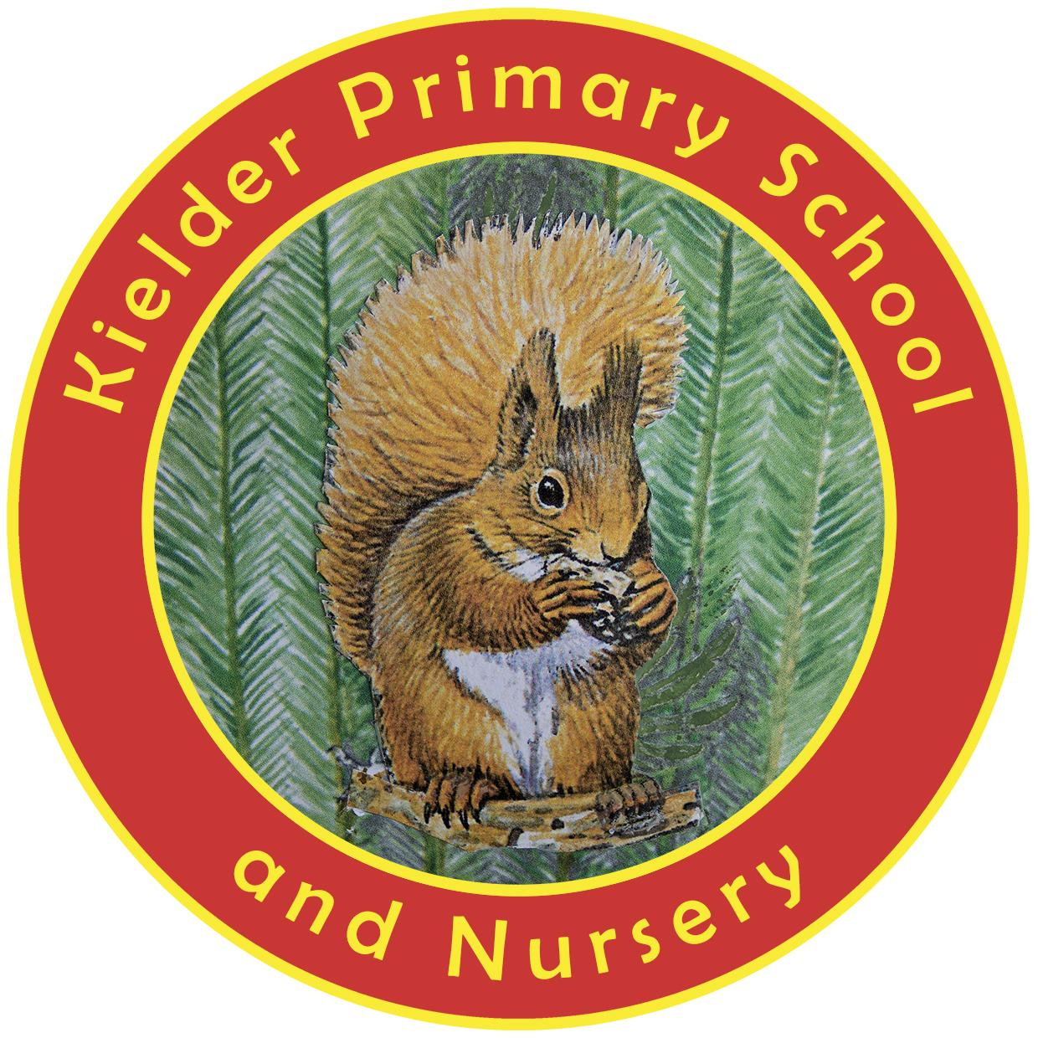

**POLICY STATUS**

| **Date approved** | **January 2025** |
| --- | --- |
| **Review cycle** | **Annual** |
| **Next review** | **January 2026** |
| **Approval level** | **Headteacher** |

**Introduction**

Effective Relationships and Sex Education (RSE) is essential if young people are to make responsible and well informed decisions about their lives. The aim is to help and support young people to learn to respect themselves, and others, and move with confidence through adolescence into adulthood. RSE should be sensitive to the circumstances of all children and mindful of the variety of expressions of family life in our culture. This policy complements the school’s key values and its programme of Personal, Social and Health Education.

**Aims and Objectives**

The aim of Relationships and Sex Education is for pupils to:

1. Understand what makes a healthy relationship
2. Understand that relationships will come in different forms
3. Know and understand how they grow and change both physically and emotionally through their lives
4. Respect and care for their own bodies and feelings
5. Understand their own right to privacy, and that of others

**Teaching and Learning**

Relationships and Sex Education is delivered in a variety of ways:

* Classroom topics
* Curriculum subjects e.g. PSHE, Science and PE
* Collective worship and assemblies
* Story/circle time
* The inclusion of other professionals

The Relationship and Sex Education programme is planned so that classroom materials and activities reflect the children’s intellectual, emotional, moral and spiritual maturity. We aim to give children correct information and challenge inappropriate language, attitudes and behaviour.

**Content**

**Children in the EYFS** will begin to develop an awareness of the aspects consolidated in KS1, through the Early Learning Goals of ‘Personal, Social and Emotional Development’ and ‘Understanding of the World’.

**Children in Key Stage 1 will learn:**

* That all animals including humans, move, feed, grow, use their senses and reproduce
* To recognise and compare the main external parts of the bodies of humans
* That humans and animals can produce offspring and these grow into adults
* To recognise similarities and differences between themselves and others, and treat others with sensitivity
* How to recognise safe and unsafe situations
* How to identify and be able to talk to someone they trust.

**Children in Key Stage 2 will learn:**

* That life processes common to humans and other animals include nutrition, growth and reproduction
* About the main stages of the human life cycle
* How to express their opinions about relationships and bullying
* How to listen and support others
* To respect other people’s viewpoints and beliefs
* To recognise their own worth and identify positive things about themselves
* The importance of recognising safe and unsafe situations
* The importance of how to identify and be able to talk to someone they trust.

**Children in Upper KS2 (Y5 and 6)** will receive additional guidance and support regarding the onset of puberty. They will also be taught about how a baby is made, and how it grows, about roles and responsibilities of parents and carers and that pregnancy can be prevented.

The curriculum followed will be based on the Kapow PSHE and RSE scheme of work and a range of other resources, including the PSHE Association’s Programme of Study. Opportunity is provided for children to talk honestly and openly but at the same time, the programmes respect the variable pace of children’s maturity.

Teachers are expected to use their professional skills and discretion when answering children’s questions. They may wish to refer children to their parents/carers or answer their questions individually at a later time. If a teacher is concerned or in any doubt, he/she should consult with the Headteacher or Chair of Governors. Should there be any disclosure or suspicion of abuse, the School’s Child Protection and Safeguarding Policy/Procedures will be followed.

**Confidentiality**

Relationship and Sex Education lessons are conducted in a sensitive manner and in confidence, whenever possible, but confidentiality cannot be guaranteed. If a child makes a reference to being involved, or likely to be involved in sexual activity, then the teacher will take the matter seriously and deal with it as a matter of child protection. Teachers will respond in a similar way if a child indicates he/she may have been a victim of abuse. In these circumstances, the teacher will, as a matter of extreme urgency, follow the procedures/ protocol laid down in the School’s Child Protection and Safeguarding Policy.

**The Role of Parents/Carers**

The school believes that the primary role in children’s relationships and sex education lies with parents/carers. We hope to build a positive and supporting relationship with parents/carers of children in our school through mutual understanding, trust and cooperation.

To achieve this objective we will:

* inform parents/carers about the School’s Relationship and Sex Education Policy.
* answer any questions they may have regarding the relationship and sex education of their child.
* consider carefully any issues that parents/carers raise with teachers or governors about this policy or the arrangements for teaching relationship and sex education.

Parents have the right to withdraw their child from all or part of the Relationships and Sex Education programme after consultation with the Headteacher.

**The Role of the Headteacher**

It is the responsibility of the Headteacher to ensure that both staff and parents/carers are informed about our Relationship and Sex Education Policy, and that it is delivered effectively. Members of staff must be given sufficient training to teach this subject effectively and handle any difficult issues with sensitivity.

**The Role of Teaching Staff**

All teaching staff will deliver the Relationships and Sex Education programme through the PSHE curriculum and other curriculum areas such as Science, conducting all lessons in a sensitive manner and with confidentiality.

**The Role of Other Members of the Community**

Visiting speakers, including the school nurse or other professionals, may be used to deliver some of the sex education and relationships programme and provide advice and support for our children. They will be qualified to do so and suitably experienced. Visitors will be accompanied, in class, by the class teacher, and any materials used will have been seen and agreed by the Headteacher before use.

The policy will be shared and discussed with parents. It will also be made available to parents/carers via the school website.