School Uniform Policy
Kielder Primary School & Nursery

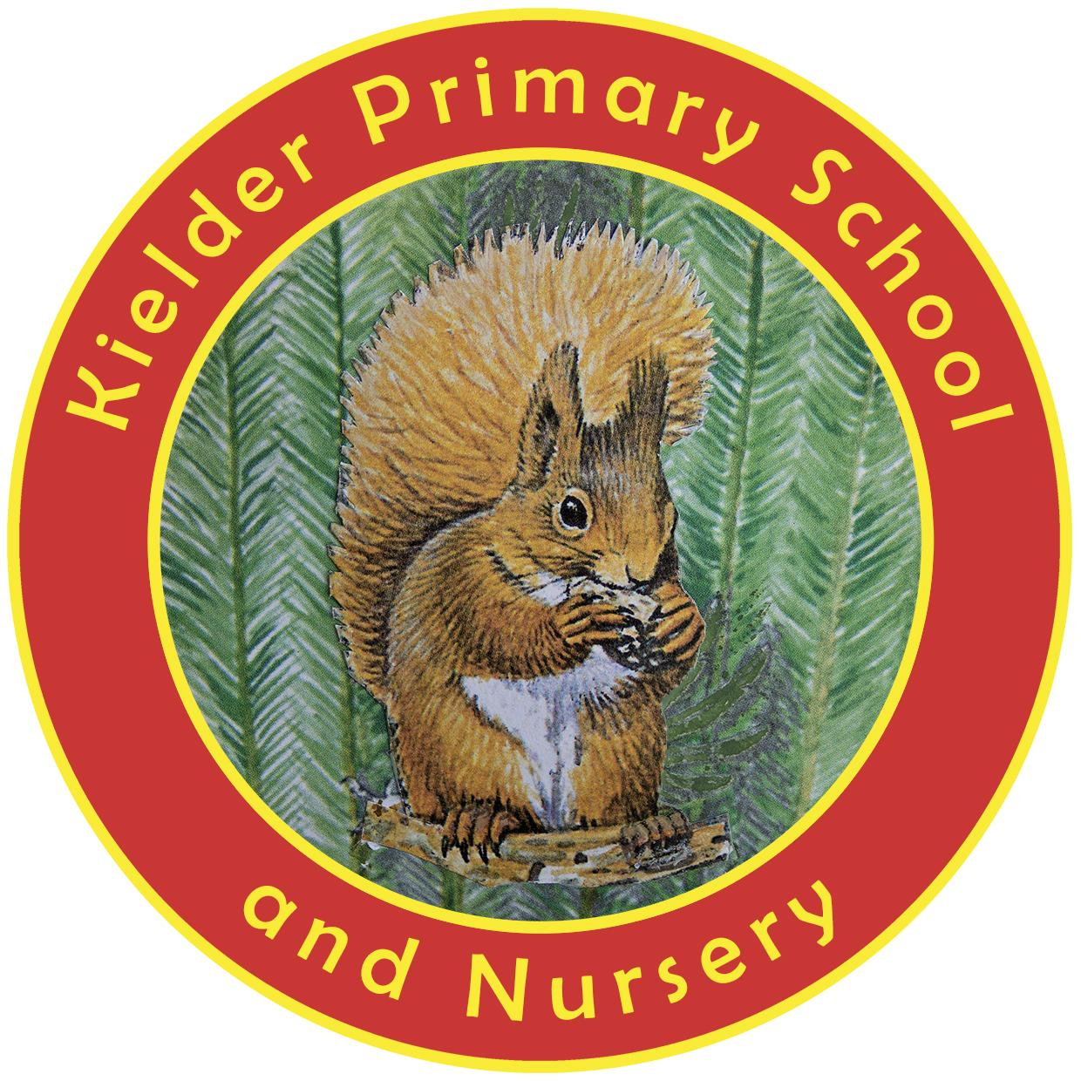

POLICY STATUS

Date approved | September 2023
Review cycle | Annual
Next review | September 2024
Approval level | Headteacher

Rationale

At Kielder Primary School, we expect all children to wear our school uniform, which is easily accessible and realistically priced. School uniform is important when the children are on school trips, but also helps provide a sense of community and belonging when the children are in school. It also helps to prepare them for the expectations of middle and secondary school, as well as working life. Larger schools are exacting in their standards regarding uniform. We believe that it does not serve our pupils well to fail to prepare them for these expectations by not establishing clear expectations of our own.

School uniform

The uniform consists of the following:
- Black or grey pinafore, skirt or trousers (available from supermarkets).
- A white polo shirt (available from supermarkets).
- A red cardigan or sweatshirt with the school logo. These need to be ordered through school.
- Sensible, well-fitting shoes suitable for playing outside.
- Summer dresses may be worn all year round over a pair of black tights, as long as they are accompanied by a school cardigan or sweatshirt in the Autumn and Spring terms.
Please see images below for examples of acceptable skirts, trousers and shoes.
Hair should be tied back where necessary and children should not wear any jewellery, including stud earrings.

PE kit

All children must have a PE kit in school every day. For reasons of health and safety, pupils may not be able to participate in sport activities without an appropriate PE kit.

Our PE kit consists of:

- A t-shirt with the school logo. These need to be ordered through school.
- Black shorts (available from supermarkets)
- PE shoes and/or trainers
- Tracksuit bottoms may be required when the children are taking part in outdoor lessons but are expressly not permitted outside of PE lessons.

PE kits should be in school every day.

We have a small amount of preloved uniform available which we offer to families before we put in any orders.

We undertake regular pricing reviews of our logo garments to ensure prices are competitive.

We encourage families to come and talk to us if they would like some help sourcing uniform.

Enforcement of School Uniform Policy

This policy will be enforced via regular uniform checks by class teachers and the Headteacher. In the first instance, specific examples of non-compliance will be discussed with parents/carers informally and guidance offered to ensure that children are provided with the correct uniform as soon as possible. Persistent failure to ensure that children attend school with the correct uniform and PE kit will result in parents/carers being invited into school for a formal meeting to discuss our expectations and establish a plan to remedy the situation. We consider the provision of appropriate uniform to be a parental responsibility; to this end, children will not be routinely punished for failure to attend school with the correct uniform.

Examples of appropriate uniform

Trousers
Smart trousers, marketed in supermarkets as school uniform trousers, are the only acceptable style of trousers, either in black or grey. On the left is an example of acceptable trousers for boys; on the right is an example of acceptable trousers for girls.
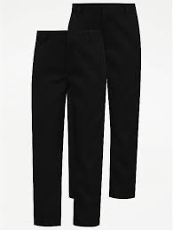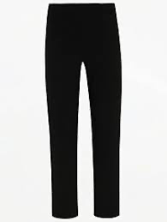

Leggings are not permitted for girls. Tracksuit trousers of any colour are expressly not permitted for any pupil.

Skirts
Skirts must be black or grey and should look similar to those below. Such skirts are readily available from supermarkets and online retailers such as Amazon.
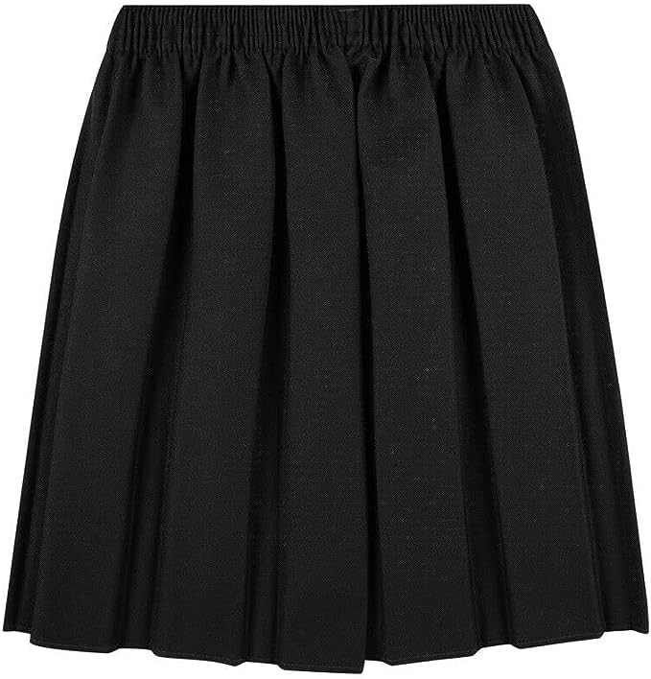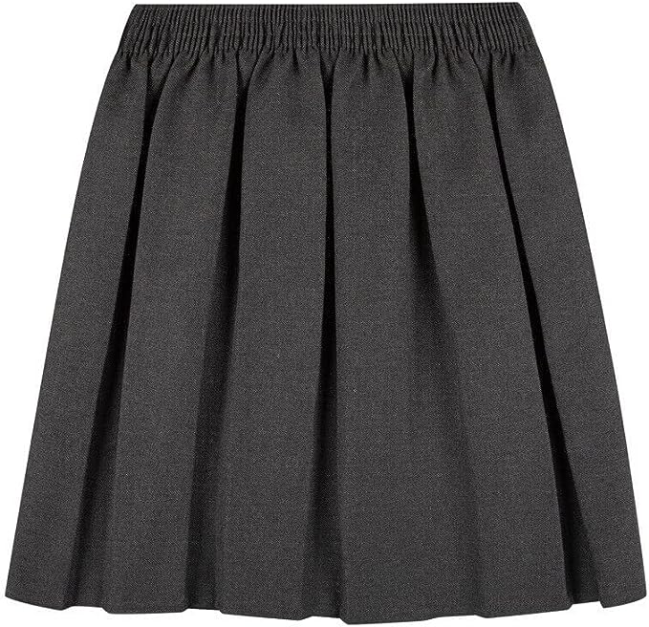

Shoes
Shoes must be appropriate for both learning and outdoor activities. Preferably, shoes should be black and smart/casual, similar to those below.
