Assessment Policy
Kielder Primary School & Nursery

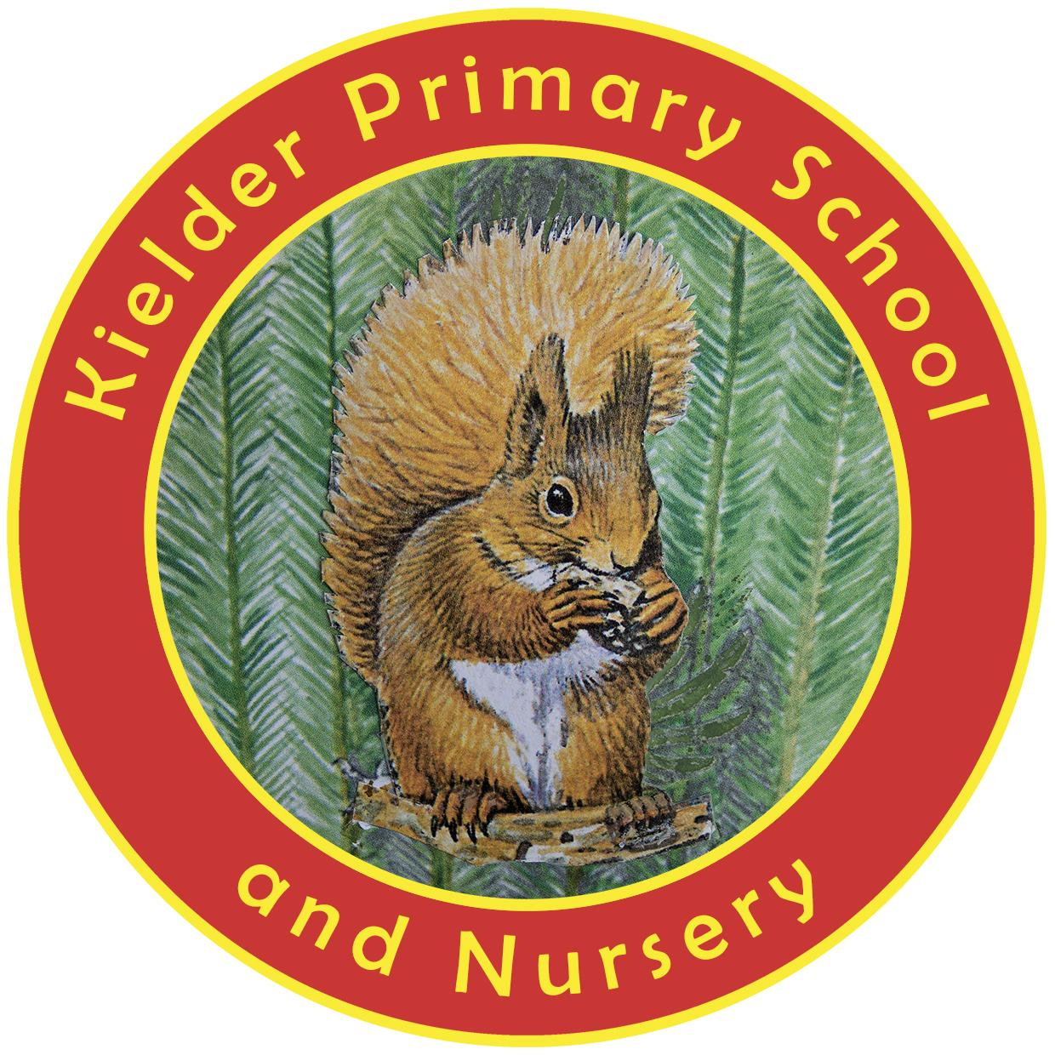

POLICY STATUS

Date approved | September 2021
Review cycle | Every 3 years
Next review | September 2024
Approval level | Headteacher

Rationale

This document should be read alongside our Marking and Feedback Policy.

At Kielder Primary School, we believe that the key aim of assessment is to support pupil achievement and progress.

Through our assessment and reporting practice, we aim to:

● Enable pupils to understand what they have to do to reach end of lesson, unit, topic, academic year and key stage expectations.
● Allow teachers to determine what a child can/cannot do and to help them plan future support to fill any gaps in knowledge and understanding.
● Help set targets and involve pupils in their own learning.
● Give parents a clear idea of what their child can do and what they need to do to progress.
● Provide information that can be used to evaluate teaching and learning practice.
● Give pupils effective feedback so they know what they have done well and what they need to improve.
● Enable all pupils, including pupils with Special Educational Needs and Disabilities (SEND) and disadvantaged pupils to make at least good progress.

Principles

The principles that underpin assessment at Kielder Primary School are:

● Every child can achieve: teachers are constantly evaluating: ‘What do I need to do next, to enable all children in my class to achieve?’ All pupils have the opportunity to access more challenging aspects of the curriculum.
● The Primary National Curriculum Programmes of Study are used as the expectations for all pupils. Assessment of pupil’s attainment and progress is directly linked to the curriculum and evaluates pupils’ knowledge and understanding of subject requirements.
● Assessment is used to ensure that all pupils make appropriate progress.
● All children need to understand the learning objective in each of their lessons and what they need to achieve it.
● Success Criteria is shared, or formulated, at the start of each session and pupils’ work is assessed against this criteria.
● Strategies are used to ensure that pupils have a secure understanding of key ideas and concepts before moving onto the next phase of learning.

There are three main types of assessment used at Kielder Primary School: 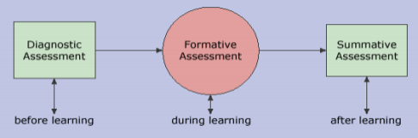

1. Pre-assessment/Diagnostic (Baseline)
At the beginning of the Autumn term, we complete baseline assessments for all the children.This informs future planning.

2. Formative Assessment (Assessment for Learning)
This type of assessment is embedded daily, across all lessons – in all subjects. Teachers assess pupils’ understanding of individual learning objectives and identify where there are gaps. This tells the teacher what to focus on in future lessons and prompts them to adapt their teaching approach to improve pupils’ understanding.
Strategies used will vary according to the subject and learning objective taught – these include:
- Use of rich question and answer sessions to evaluate pupil understanding and identify gaps or misconceptions.
- Use of whiteboards, flip charts and number fans to get instant feedback of understanding.
- Mini-plenaries to determine understanding at regular intervals.
- Short recap quizzes or recall of facts.
- In mathematics lessons, teachers often focus on the wrong answers (which can be used to explore concepts in greater depth and to identify and address any misconceptions).
- Observational assessment.
- Scanning work for pupil attainment and progress.
- Self (or peer) assessment at the end of every lesson based on individual learning objectives and Success Criteria.
- 1:1 or group discussions with pupils.
- Next step marking and feedback (see Marking and Feedback Policy).

3. Summative assessment (Assessment of the Learning)
This is used to evaluate how much a pupil has learned at the end of a teaching period (end of a Unit/Topic, term or academic year).

Standard Assessment Tests
This type of summative assessment is used by the Government to hold schools to account and to provide information on how pupils are performing in comparison to pupils nationally.

At the end of KS1 and KS2, pupils will be given a scaled score and a ‘performance descriptor’ against the expected standard.

Assessment by year group
Year | Phonics | Writing | Maths | Reading | GPS | Science
R  Government Baseline Assessment | Read Write Inc teacher assessment | ELG profile teacher assessment | ELG profile teacher  assessment/  PUMA test | ELG profile teacher assessment/ PUMA test | ELG profile  teacher  assessment | ELG profile assessment
1 | Y1 National  Phonics  screening check | Teacher  assessment (assessed  piece) | Published  standardised  test/teacher  assessment | Published  standardised test/teacher  assessment | Test/teacher  assessment | Test/teacher  assessment
2 | Read Write Inc  teacher assessment | Y2 SATS | Y2 SATS | Y2 SATS | Y2 SATS (optional) | Test/teacher  assessment
3 | N/A | Teacher  assessment | Published  standardised test/teacher  assessment | Published  standardised test/teacher  assessment | Test/teacher  assessment | Test/teacher  assessment
4 | N/A | Teacher  assessment | Published  standardised test/teacher  assessment | Published  standardised test/teacher  assessment | Test/teacher  assessment | Test/teacher  assessment
5 | N/A | Teacher  assessment | Published  standardised test/teacher  assessment | Published  standardised test/teacher  assessment | Teacher  assessment | Teacher  assessment
6 | N/A | Year 6  SATS | Year 6  SATS | Year 6  SATS | Year 6  SATS | Year 6  SATS

As a school, we use nationally standardised summative assessment to benchmark our school’s performance against other schools locally and nationally. We also moderate with other schools to ensure our judgements are accurate.

Assessment in the Early Years Foundation Stage (EYFS)
At the beginning of Nursery and Reception, the children are assessed against the Prime Areas and Specific Areas of Learning in the EYFS.

EYFS assessment is continuous.Practitioners use the EYFS strands/Early Learning Goals (ELGs) as a part of their daily observation, assessment and planning.

On-going formative assessment is at the heart of effective early years practice.

The early years’ staff make regular observations of how children act and interact and take photographs and make notes of what they can do to help identify where they may be in their own developmental pathway.

Activities are either adult-led or child-initiated through play.

Teachers collect this evidence using the Tapestry program on their iPads. If a teacher attaches a photo, or other evidence, to a EYFS strand this will be digitally transferred to the children’s individual profile and can also be shared with parents in line with GDPR legislation.

Key workers log onto Tapestry daily and use evidence collected to inform their judgements of whether pupils are ‘Emerging, Developing or Secure’ in each aspect of the early years ages and stages. These levels are used to help track pupil progress.

When tracking progress, this information is not looked at in isolation but alongside evidence in pupil books, ongoing assessments, observations and notes. Analysis of data is used to inform individual pupil targets and support as well as whole class coverage of gaps in knowledge.

EYFS Profile
In the Summer term of Reception, the EYFS Profile is completed for each child. This provides parents, carers and practitioners with a well-rounded picture of a child’s knowledge, understanding and abilities, their progress against expected levels, and their readiness for Year 1.

This data is collated to ascertain if the child has achieved a GLD (Good Level of Development). The Government collects this data to judge the school against national expectations.

Recording of Attainment
National Curriculum Assessment  (Years 1-6) | Working Towards (WTS) | Expected  (EXS) | Greater Depth  Standard (above expected)  (GDS)
EYFS Assessment  (Nursery and Reception) | Emerging  (E) | Developing  (D) | Secure  (S)

At the end of Reception children are awarded GLD (Good level of Development) if they have achieved the ELG (Early Learning Goals) in the EYFS curriculum areas of Personal, Social and Emotional Development, Physical Development, Communication and Language Development, Literacy and Mathematics.

We also use Passport. This is a tool that tracks progress and ensures continuity with progression.

What do these levels mean?
EYFS
Emerging (E) | Yet to be secure in the end of year expectations. | Expected to achieve in the child’s year group by the end of Autumn Term.
Developing (D) | Secure in the majority of the end of year expectations. | Expected to achieve in the child’s year group by the end of Spring Term.
Secure (S) | Secure in almost all the end of year expectations and is able to use and  apply their knowledge and skills confidently. | Expected to achieve in the child’s year group by the end of Summer Term.

Years 1-6
Working Towards  (WTS) | Yet to be at the expected level for the end of year expectations. | Expected to achieve in the child’s year group by the end of Autumn Term.
Expected (EXS) | At expected level, achieved most of the end of year expectations. | Expected to achieve in the child’s year group by the end of Spring Term.
Exceeding (GDS) | Exceeding in all the end of year  expectations. | Exceeding expectations in the child’s year group by the end of Summer Term and applying their skills to all areas of the curriculum.

The Headteacher makes judgements about the school’s effectiveness and analysis of data is used to inform the School Development Plan.

