Packed Lunch Policy
Kielder Primary School & Nursery

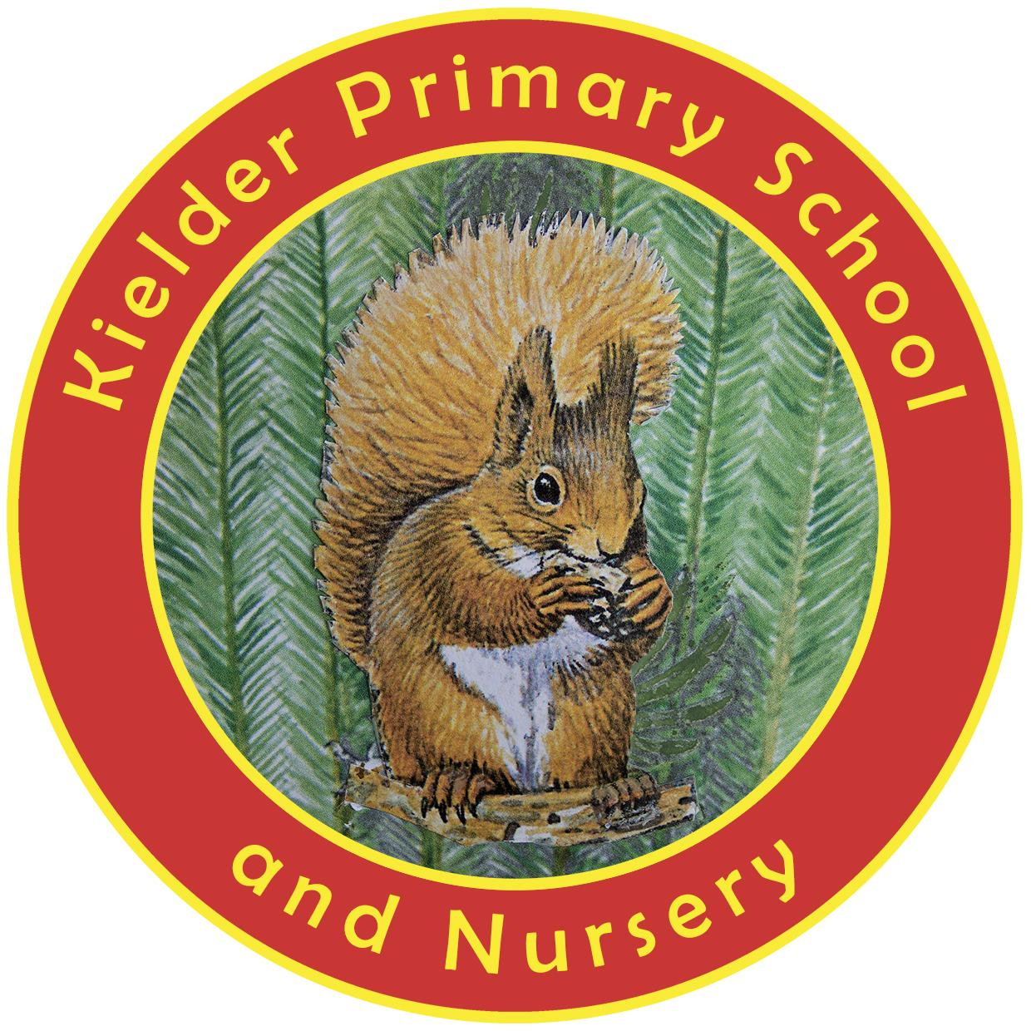

POLICY STATUS

Date approved | September 2023
Review cycle | Every 4 years
Next review | September 2027
Approval level | Headteacher

Overall aim of the policy

To ensure that all packed lunches brought from home and consumed in school (or on school trips) provide the pupil with healthy and nutritious food that is similar to food served in schools, which is now regulated by national standards.

Food and drink in packed lunches

- The school will provide facilities for pupils bringing in packed lunches and ensure that free, fresh drinking water is readily available at all times.
- The school will work with the pupils to provide attractive and appropriate dining room arrangements.
- The school will work with parents to ensure that packed lunches meet the standards listed below.
- As fridge space is not available in school, pupils are advised to bring packed lunches in insulated bags with freezer blocks where possible, to stop the food going off.
- Wherever possible, the school will ensure that packed lunch pupils and school dinner pupils will be able to sit and eat together.

Packed lunches should include:

- at least one portion of fruit and one portion of vegetables every day.
- meat, fish or other source of non-dairy protein (e.g. lentils, kidney beans, chickpeas, houmous, peanut butter and falafel) every day.
- oily fish, such as salmon, at least once every three weeks.
- a starchy food such as any type of bread, pasta, rice, couscous, noodles, potatoes or other type of cereals every day.
- dairy food such as milk, cheese, yoghurt, fromage frais or custard every day or non-dairy alternatives
- school will provide a drink, so this does not need to be included.

Packed lunches should not include:

- snacks such as crisps. Instead, include nuts, seeds, vegetables and fruit - with no added salt, sugar or fat - savoury crackers or breadsticks served with fruit, vegetables or dairy food.
- confectionery such as chocolate bars, chocolate-coated biscuits and sweets (cakes and biscuits are allowed but encourage your child to eat these only as part of a balanced meal.)
Meat products such as sausage rolls, individual pies, corned meat and sausages should be included only occasionally.

Special diets and allergies

Visit www.allergyuk.org and www.food.gov.uk for information on managing allergies in schools.

The school recognises that some pupils may require special diets that don’t exactly conform to the school food standards. So parents should take extra care to ensure those packed lunches are as healthy as possible and discourage their children from swapping food items.

Assessment, evaluation and reviewing

Packed lunches will be regularly reviewed by staff
Please note: pupils with special diets will be given due consideration.

Involvement of parents/carers

Pupils are normally expected to eat the lunch provided by the school. However, parents of pupils wishing to have packed lunches for a particular reason are expected to provide their children with packed lunches which conform to the packed lunch policy.

The school will use opportunities such as parents’ evenings and healthy living weeks to promote this policy as part of a whole school approach to healthier eating.

