Physical Activity Policy
Kielder Primary School & Nursery

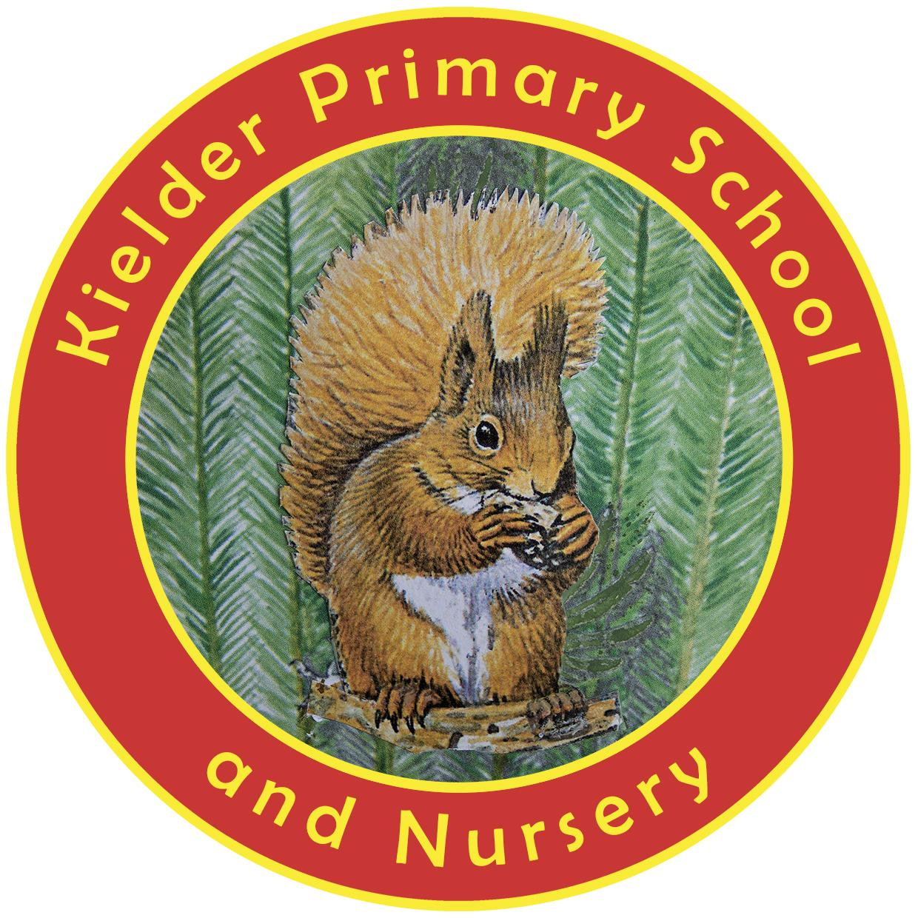

POLICY STATUS

Date approved | September 2023
Review cycle | Every 2 years
Next review | September 2025
Approval level | Headteacher

At Kielder Primary School, we have a responsibility to help pupils and staff establish and maintain a healthy lifestyle. Regular physical activity is one of the most important ways people can maintain and improve their physical health, mental health and overall well-being.

Therefore, it is important that our pupils are given opportunities to participate in a range of enjoyable physical activities at an early age so they are more likely to continue being physically active throughout the rest of their lives.

The planned use of the PE and Sport Premium money will be extremely effective in improving and sustaining high quality PE and sports provision.

Our Aims

- To implement the National Curriculum fully.
- To promote the benefits of physical activity to the whole school.
- To improve the self-esteem and confidence of the pupils through participation in physical activity.
- To develop coordination, skills and fitness through a range of physical activities.
- To adopt a healthy attitude towards sport in order to promote future health and well-being and to demonstrate a respect for others and the environment.
- To raise the awareness of the increasing need for good personal hygiene, particularly in relation to physical activities.
- To promote the celebration of sporting events.
- To provide opportunities for participation, enjoyment and success irrespective of age, ability or gender.
- To provide opportunities for all children to achieve their full potential and to meet their own challenges.
- To improve the quality and breadth of PE and Sport.
- To ensure safe practice by developing an understanding of safety procedures and enabling children to apply them in different contexts.
- To abide by rules and demonstrate good sporting behaviour.

Definition of physical activity

Physical activity is defined as ‘any force exerted by skeletal muscle that results in energy expenditure above resting level’ and includes ‘the full range of human movement, from competitive sport and exercise to active hobbies, walking and cycling or activities of daily living’.

Entitlement

The children are timetabled for weekly sessions as follows:

Early Years Daily outdoor physical activity. Access to continuous provision. Daily ‘Wake up, shake up!’

Reception and Key Stage One: Two hours of high quality PE. Daily ‘Wake up, shake up!’

Key Stage Two: Two hours of high quality PE (swimming is accessed by Years 3/4/5/6). Daily ‘Wake up, shake up!’

The Learning Environment: At Kielder, we have one large sports hall, a large playground area and access to a large grass area at the front of school. Early Years have their own fenced outdoor area with a play house and outdoor play equipment.

Our Delivery

At Kielder, we strive to provide high quality PE lessons.

The promotion of physical activity is delivered through:

- Physical education lessons each week led by one of our class teachers
- Crosscurricular links in our curriculum.
- Extracurricular after school clubs or at lunchtime e.g. Healthier Families.
- Structured play and lunchtime activities e.g. skipping.
- Daily 10 minutes of ‘Wake up, Shake up!’. This ‘Ready to Learn’ exercise helps with coordination, core strength and overall levels of physical literacy.
- ‘Brain breaks’ or ‘Brain Gym’ in between lessons.
- Classroom yoga.
- Stories in Motion - ‘Active Story’ activities.

As a school, we are signed up with the ‘Walk to School’ programme. Each morning, the children take ownership of this and record their journey to school on the interactive whiteboard. The children earn badges relating to how many times they walked, ran or cycled to school etc.

The PE Curriculum

Teachers plan from the National Curriculum objectives.

This PE programme offers continuity and progression in all areas. PE teaching generally takes the form of a whole class lesson following a clear structure:

- Introductory activity/warm up
- Main skill activity
- Application and evaluation
- Cool down/concluding activity

Partnership

Our school is in partnership with Bellingham, Otterburn, Wark and Greenhaugh Primary Schools. This means we have access to support and training in the delivery of good quality PE lessons in games, dance, gymnastics, athletics and outdoor activities.

We also offer swimming lessons in curriculum time to ensure that our children meet and almost always exceed the national minimum expectations for swimming.

Minibus

We rent a school minibus that is funded by Sport Premium money. We use the bus to drive the children to sporting events within our partnership.

Crosscurricular links

PE can be and is used where possible to enhance the learning in core and foundation subjects. There are many opportunities to develop speaking and listening skills through questioning, answering, appreciation and evaluation of activities. For example, in dance, poetry, story and music can be explored, as well as elements of number shape, space and measure.

Extracurricular physical activity

We have a range of extracurricular activities e.g. Healthier Families, gardening etc., which aim to enhance and extend the PE curriculum. Clubs are led by a member of staff. We are part of a cluster of schools and regularly take part in different festivals and tournaments for pupils of different ages, working proactively with Active Northumberland. We are also working with the Opening School Facilities programme to explore opportunities for more after-school sports activities involving the children and their community.

Physical equal opportunities

All pupils in our school, including those with special needs, are entitled to a comprehensive programme of physical education which fulfils the statutory National Curriculum requirements and takes into account their individual needs and interests. It may be necessary to amend the activities to meet the needs of individual pupils. We encourage all pupils to participate in extracurricular activities, whatever their levels of ability.

Pupils are taught in mixed age groups and we consider it vital that all pupils: girls, boys, those with low attainment and those with high attainment, irrespective of ethnic and social background, are given access to a full PE curriculum in accordance with our schools Equality Policy.

All pupils who are identified as having SEN are integrated into mainstream PE lessons, which are appropriately differentiated.

Awards
We currently hold a Schools Games Platinum award.

Policies
We have a Packed Lunch Policy to promote healthy eating habits.

Health and Safety

The following conditions must be adhered to in PE activities:

- Children are requested to have an appropriate PE kit in school consisting of shorts, t-shirt and appropriate footwear.
- The teacher should consider the amount of time children are outside in direct sunlight
- The children get changed in their classroom.
- Staff should dress appropriately for PE lessons.
- Jewellery should not be worn.
- Long hair should be tied back.
- Dealing with and reporting accidents or injuries that occur in lessons should be dealt with in accordance with the established system.
- Children should be encouraged to get out and put away their own apparatus.
- Gymnastics equipment should always be moved with at least two children carrying it. Larger pieces of equipment should be carried by at least four children. Children will be taught how to do this.
- Staff should check all equipment prior to use.

